**Student Name: Sandesh Joshi**

**ID: 6143**

**Task 1 - Getting started with moqups.com account setup and tools overview**

Task 1 is finished as I have already created a free account in moqups.com

**Task 2 – Design the below like wireframe structure. Use your own creativity.**

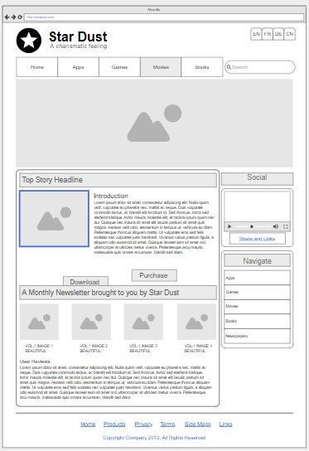

This is the wireframe structure I created like given on a question in moqups.com.

**Task 3 – Create a mockup design like your college website’s contact us page. Use your own creativity for this design.**

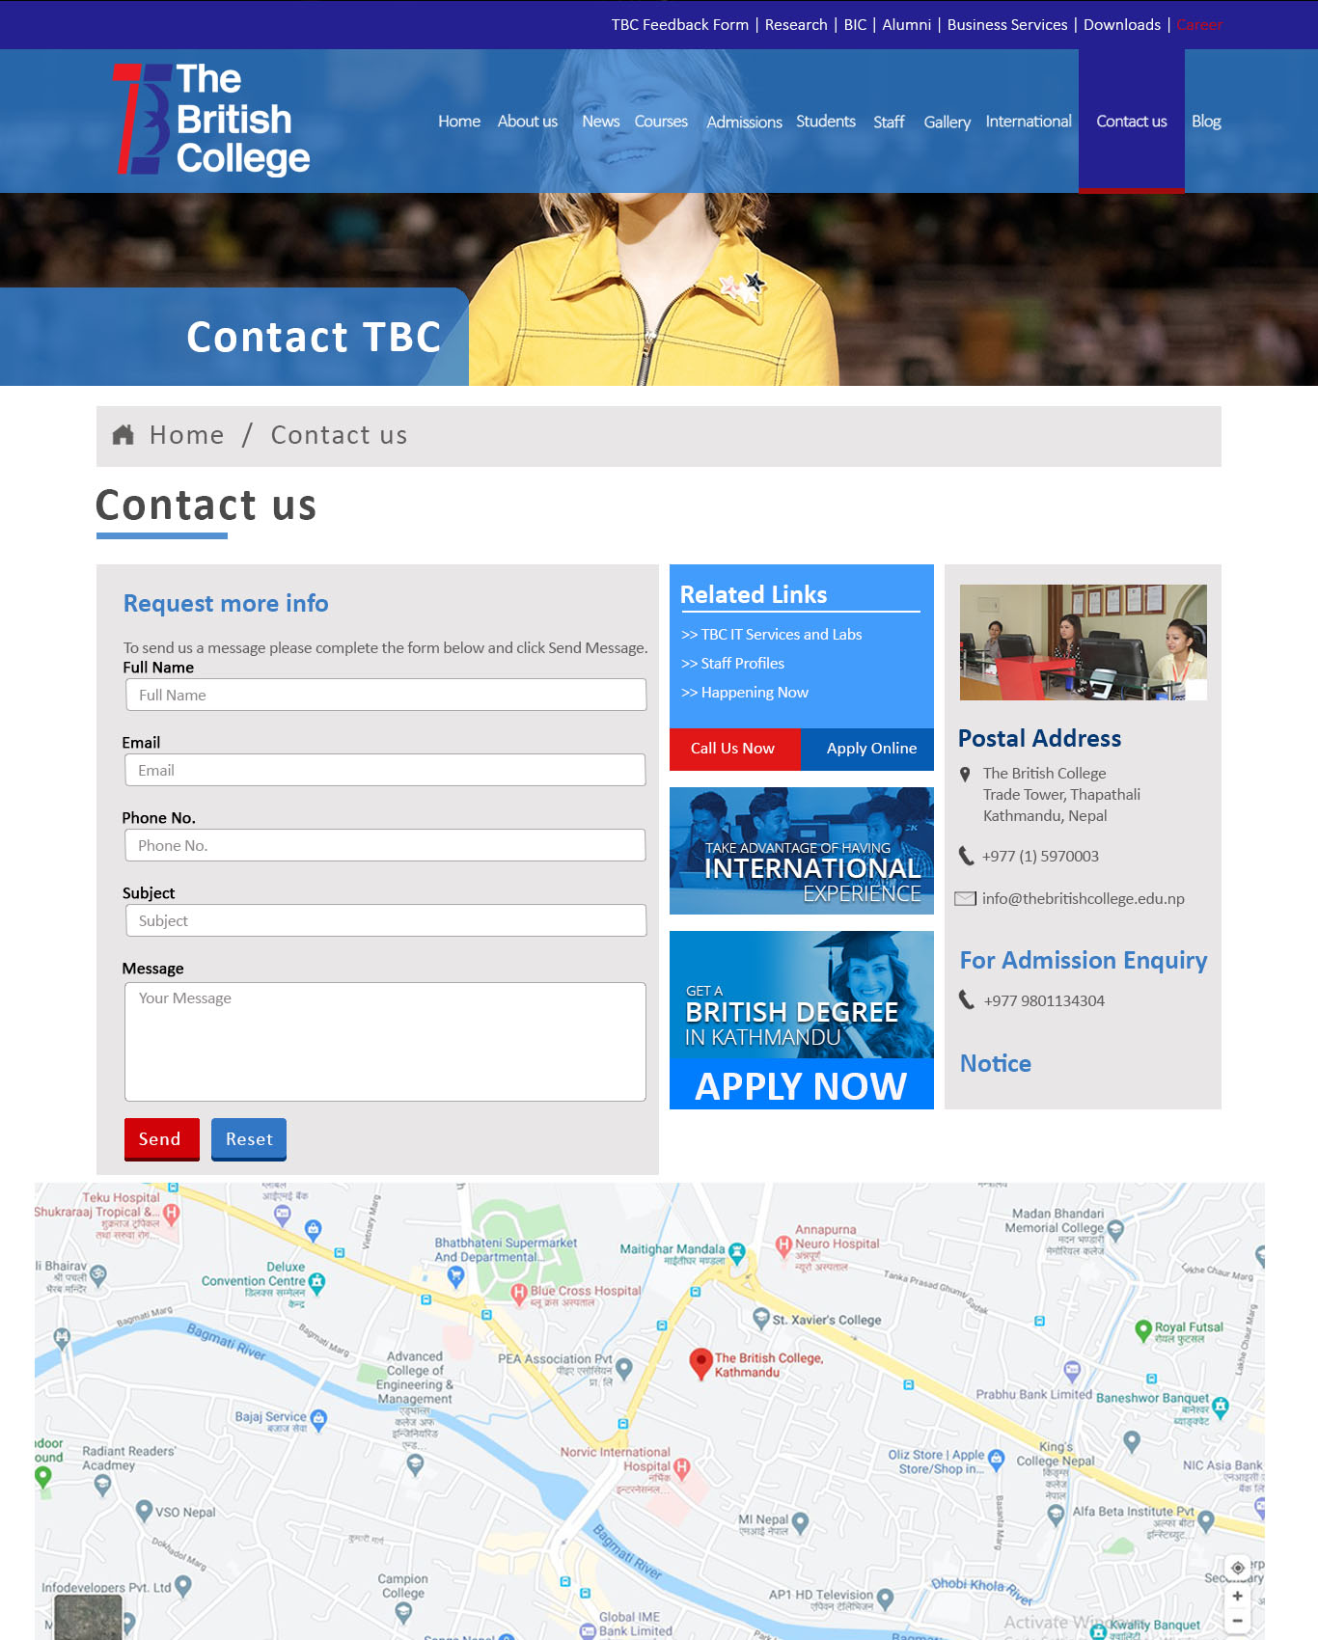

It’s the mockup design made in Adobe Photoshop like our college websites contact us page.